MiniProject Title: ***INVENTORY MANAGEMENT***

Authors: ***ANTHONY BERNARD CERENO, KRISTINE OSEA***

# **Project Overview**

In these challenging times, people are constantly looking for ways to improve their lives and increase their income. As the saying goes, *"If you want to become a scientist, learn from scientists. But if you want to become a millionaire, learn from millionaires." -Anonymous.* Entrepreneurship is a great way to do this, and many people start by running a business while also working full-time. However, this can be stressful and time-consuming, and it can be difficult to keep track of everything while you're away from your business.

But with our inventory management system, you can stay in control of your business no matter where you are. Imagine being able to check your phone and with just a few clicks, you can notify your staff and stay informed about what's happening in your business. For those who are serious about becoming wealthy, ***Time is Money*** ***And with our inventory management system, you'll save both.***

1. **Statement of the Problem**

The propose Inventory management project aims to provide solution on a common problem encountered by a most business owners due to poor inventory management system.

Specifically, on the following questions:

1. How to prevent in demand product from running out of stock?

2. How minimize overstock product?

3. How to avoid losing sales due to expiry or expired product.

4. How to choose better supplier amongst existing one?

5. How to minimize stolen goods?

## **B. Project Solution**

The general solution or objective of this project was to develop “Inventory Management System” a clear, accurate and effective one.

1. Real-time updates on stock levels
2. Compare product performance from past and present
3. Provide alerts when items are low
4. Identify itesm that are hard to sell
5. Provide detailed reports and Analytic
6. Only authorized persons set by owner will access the invetory/warehouse

# **System Features**

An accurate and effective inventory management is crucial to the success of a business. Our Inventory Management System streamlines the ordering and reordering process by recording supplier details, ordered product information, and stock received. The system also tracks sales and predicts stock needs to prevent overstocking or running out of stock. It sends alerts for near-expiry products and warns of a potential stock shortage. This system will save time, increase efficiency, and improve customer satisfaction. Invest in our Inventory Management System for a smarter and more product Management.

A. **User Management**: The Inventory Management Web App will have individual logins for every person who is part of the company. Each person will have their own set of authorities and limitations.

B. **Inventory Tracking**: Every item will be registered through barcode scanning and the information will be recorded in the web app.

C. **Order Management**: Every time an item is taken out of the warehouse or inventory, the barcode will be entered into the order management section, where the information will be recorded and passed to the inventory tracking to deduct the item count.

D. **Real-time Reporting and Analytics**: All the information gathered will be calculated and sent to the web app for analysis. The app will compare the performance of each product over time, such as daily, weekly, monthly, etc.

E. **Notifications**: After the web app has analyzed the data, it will send notifications to the end-user, as per their pre-defined settings.

F. **Staff Management**: The owner or administrator can assign different levels of authorities to employees based on their roles and responsibilities.

G. **Product Management**: The owner or authorized personnel can edit information about the products, such as item counts, descriptions, etc.

# **Limitations**

The project focuses on developing a web application: “Inventory Management” that will help Entrepreneurs to manage their business easily and cost effective to save time and Money.

The limitations of the "Inventory Management" web app are:

1. Limited to only tracking in/out items in the warehouse/inventory

2. Dependent on internet connectivity

3. Requires physical device/smartphone for all staff members

4. May have compatibility issues with different devices and operating systems

5. Security concerns such as data privacy and hacking risks

6. Possible downtime due to technical issues or maintenance needs

7. Potential limitations in scalability as the business grows

8. Limited customization options

# **Theme, Fonts, logo, Technology used**

**Theme:**

**Font:**

* Inter
* 64
* 24
* 16
* 12

**Logo:**



**Technology used:**

* HTML 5
* CSS 3
* Bootstrap
* Figma.com
* Canva.com
* Logo.com

# **Site Map**

www.portfolio.com.test/miniproject1/index.html

LVL 0

LANDING PAGE

LVL 1

LOGIN

SIGN-UP

LVL 2

STORE

LVL 3

SUPPLIERS

ADD PRODUCT

STAFFS

ORDERS

SETTINGS

MAINTENANCE

# Mockup/Wireframe

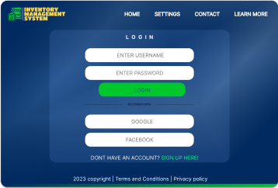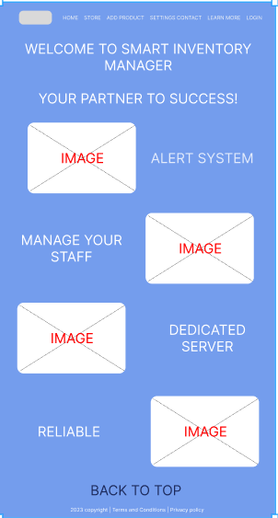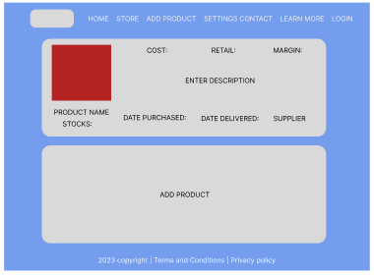

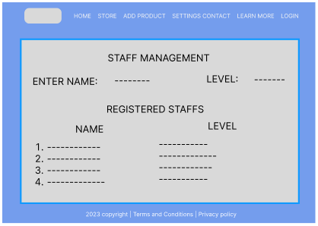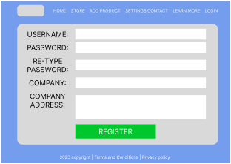

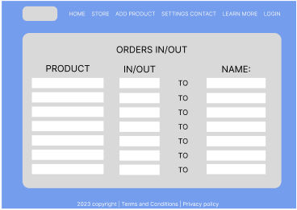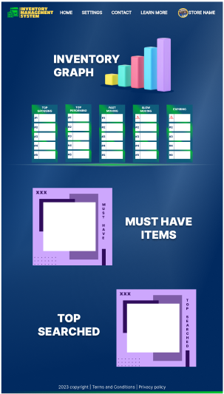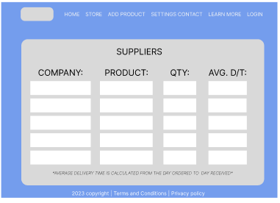

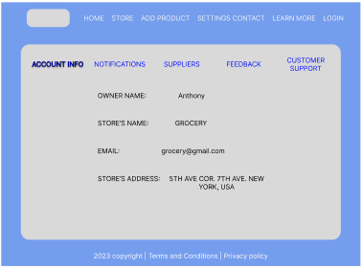



# Web App URL:

Sources:

https://www.netsuite.com/portal/resource/articles/inventory-management/inventory-management.shtml#:~:text=Inventory%20management%20helps%20companies%20identify,proper%20warning%20of%20a%20shortage.